**MALE REPRODUCTIVE SYSTEM**

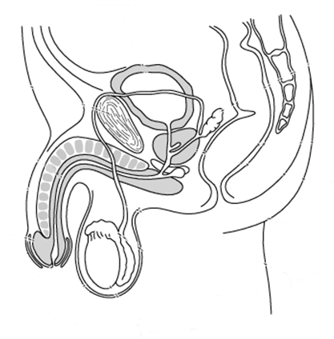

**A**

**B**

**C**

**D**

**E**

**F**

**G**

**H**

**I**

1. Complete the following table by entering the correct label from the diagram above and then write down the function of each structure.

|  |  |  |
| --- | --- | --- |
| Structure | Letter | Function |
| Testis |  |  |
| Epididymis |  |  |
| Scrotum |  |  |
| Vas deferens |  |  |
| Seminal vesicle |  |  |
| Prostate |  |  |
| Bulbo-urethral gland |  |  |
| Urethra |  |  |
| Penis |  |  |

1. Where are the sperm produced? Indicate this on the diagram on the previous page.
2. Where are the sperm stored? Indicate this on the diagram on the previous page.
3. Which part of the male reproductive system is held at a different temperature from the rest of the body? Explain why.
4. What flows through tube A?
5. Name the two types of fluid that flow through tube C?
6. Describe the structural differences between a spermatid and a spermatozoon?

Below is a diagram of a sperm.

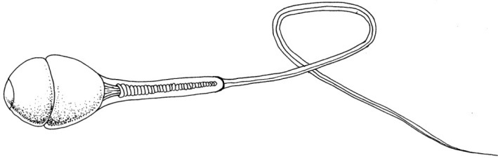

1. Label the acrosome, head, mid-piece, mitochondria and flagellum.
2. The acrosome helps the sperm penetrate the ovum. Name the two layers through which the sperm must pass before entering the ovum.
3. Below is a list of sex cells. Circle those cells that are diploid.

*Primary spermatocyte, zygote, spermatozoa, spermatogonia*

**FEMALE REPRODUCTIVE SYSTEM**

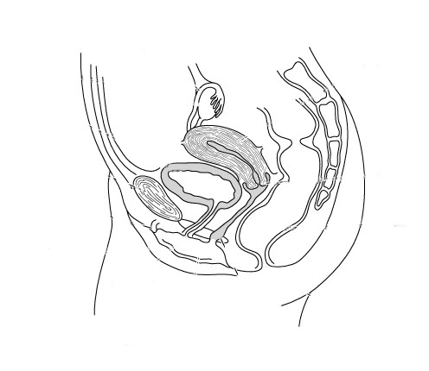

**A**

**F**

**B**

**C**

**E**

**G**

**D**

1. Complete the following table by entering the correct label from the diagram above and then write down the function of each structure.

|  |  |  |
| --- | --- | --- |
| Structure | Letter | Function |
| Ovary |  |  |
| Clitoris |  |  |
| Oviduct |  |  |
| Uterus |  |  |
| Cervix |  |  |
| Vagina |  |  |
| Urethra |  |  |

1. On the diagram above use labelled arrows to indicate the site where the following events occur:

* Sperm are deposited
* Ova are formed
* Fertilisation normally occurs
* Implantation most frequently occurs

**THE OVARIAN AND MENSTRUAL CYCLES**

The diagram below shows the various structures that may be visible in an ovary when it is viewed under a light microscope

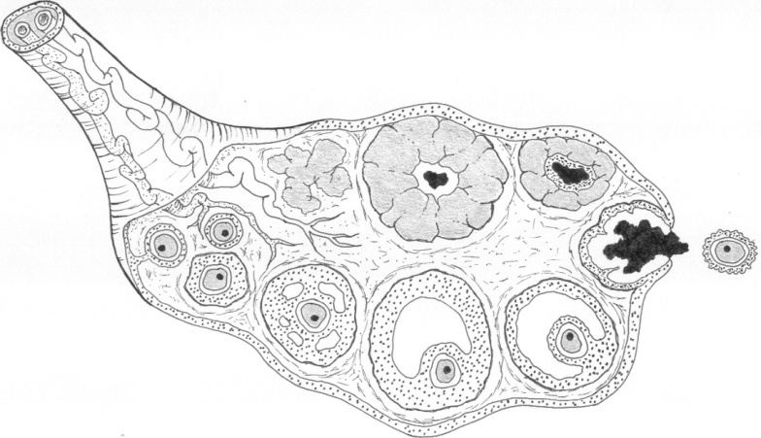

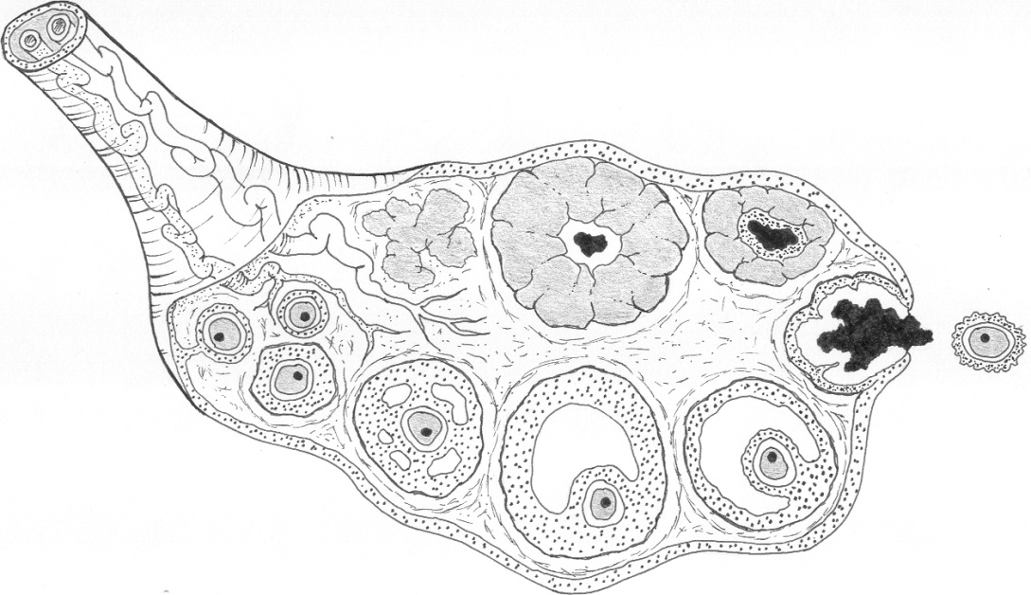

1. Label the diagram with the following words:

*Developing follicle / Mature follicle / Secondary oocyte / Ovulation*

*Corpus luteum / Degeneration of corpus luteum*

1. Which structures in the ovary are under the influence of the hormone FSH?
2. Which event is stimulated by the hormone LH?
3. In a 28-day cycle, on which day does the hormone LH reach a peak?
4. Name the hormone secreted by the follicle cells and describe its function.
5. Name the main hormone secreted by corpus luteum and describe its function.
6. How are sperm able to penetrate the corona radiata and zona pellucida to bring about fertilisation?
7. The fusion of the sperm and the egg causes a chemical change to the surface of the egg and blocks further sperm entry. Why is it necessary to prevent the entry of more than one sperm?
8. Approximately how long does the egg remain alive after ovulation if it is not fertilised?
9. Describe the role of FSH and LH in males. Where are these hormones produced?
10. What is menstruation? For approximately how many days does menstruation usually last?
11. What is the difference between menarche and menopause?
12. The following table gives an analysis of the blood of a female over a period of 28 days, showing the levels of FSH and LH. Draw a line graph of this data on the axes on the next page.

|  |  |  |  |  |  |  |  |  |
| --- | --- | --- | --- | --- | --- | --- | --- | --- |
| Day | Units of FSH | Day | Units of FSH |  | Day | Units of LH | Day | Units of LH |
| 1 | 9 | 15 | 11 |  | 1 | 11 | 15 | 11 |
| 3 | 12 | 17 | 8 |  | 3 | 13 | 17 | 11 |
| 5 | 15 | 19 | 8 |  | 5 | 13 | 19 | 11 |
| 7 | 14 | 21 | 7 |  | 7 | 14 | 21 | 11 |
| 9 | 13 | 23 | 7 |  | 9 | 14 | 23 | 11 |
| 11 | 15 | 25 | 7 |  | 11 | 17 | 25 | 7 |
| 13 | 22 | 27 | 9 |  | 13 | 72 | 27 | 7 |

**Graph showing the changes in concentration of the sex hormones during a 28-day cycle**

|  |  |  |  |  |  |  |  |  |  |  |  |  |  |  |  |  |  |  |  |  |  |  |  |  |  |  |  |
| --- | --- | --- | --- | --- | --- | --- | --- | --- | --- | --- | --- | --- | --- | --- | --- | --- | --- | --- | --- | --- | --- | --- | --- | --- | --- | --- | --- |
|  |  |  |  |  |  |  |  |  |  |  |  |  |  |  |  |  |  |  |  |  |  |  |  |  |  |  |  |
|  |  |  |  |  |  |  |  |  |  |  |  |  |  |  |  |  |  |  |  |  |  |  |  |  |  |  |  |
|  |  |  |  |  |  |  |  |  |  |  |  |  |  |  |  |  |  |  |  |  |  |  |  |  |  |  |  |
|  |  |  |  |  |  |  |  |  |  |  |  |  |  |  |  |  |  |  |  |  |  |  |  |  |  |  |  |
|  |  |  |  |  |  |  |  |  |  |  |  |  |  |  |  |  |  |  |  |  |  |  |  |  |  |  |  |
|  |  |  |  |  |  |  |  |  |  |  |  |  |  |  |  |  |  |  |  |  |  |  |  |  |  |  |  |
|  |  |  |  |  |  |  |  |  |  |  |  |  |  |  |  |  |  |  |  |  |  |  |  |  |  |  |  |
|  |  |  |  |  |  |  |  |  |  |  |  |  |  |  |  |  |  |  |  |  |  |  |  |  |  |  |  |
|  |  |  |  |  |  |  |  |  |  |  |  |  |  |  |  |  |  |  |  |  |  |  |  |  |  |  |  |
|  |  |  |  |  |  |  |  |  |  |  |  |  |  |  |  |  |  |  |  |  |  |  |  |  |  |  |  |
|  |  |  |  |  |  |  |  |  |  |  |  |  |  |  |  |  |  |  |  |  |  |  |  |  |  |  |  |
|  |  |  |  |  |  |  |  |  |  |  |  |  |  |  |  |  |  |  |  |  |  |  |  |  |  |  |  |
|  |  |  |  |  |  |  |  |  |  |  |  |  |  |  |  |  |  |  |  |  |  |  |  |  |  |  |  |
|  |  |  |  |  |  |  |  |  |  |  |  |  |  |  |  |  |  |  |  |  |  |  |  |  |  |  |  |
|  |  |  |  |  |  |  |  |  |  |  |  |  |  |  |  |  |  |  |  |  |  |  |  |  |  |  |  |

1. Sketch in two more lines to show the changes in the blood concentration of oestrogen and progesterone over the 28-day cycle.
2. In the appropriate boxes above the graph, sketch a diagram representing: a developing follicle, a mature follicle, ovulation, the corpus luteum, and the degenerating corpus luteum.
3. Describe the changes to the uterine wall (endometrium) during a menstrual cycle.
4. Briefly describe the changes in the wall of the uterus if the ovum is not fertilised.
5. What changes occur to the wall if the ovum is fertilised?

**EARLY GROWTH AND DEVELOPMENT**

The diagram below shows some of the key structures and events during the first two weeks of pregnancy.

1. Label the diagram using the following terms

*Morula / inner cell mass / fertilisation / ovum / spermatozoa / implantation*

*endometrium / blastocyst / ovary / 4-cell stage / ovulation*

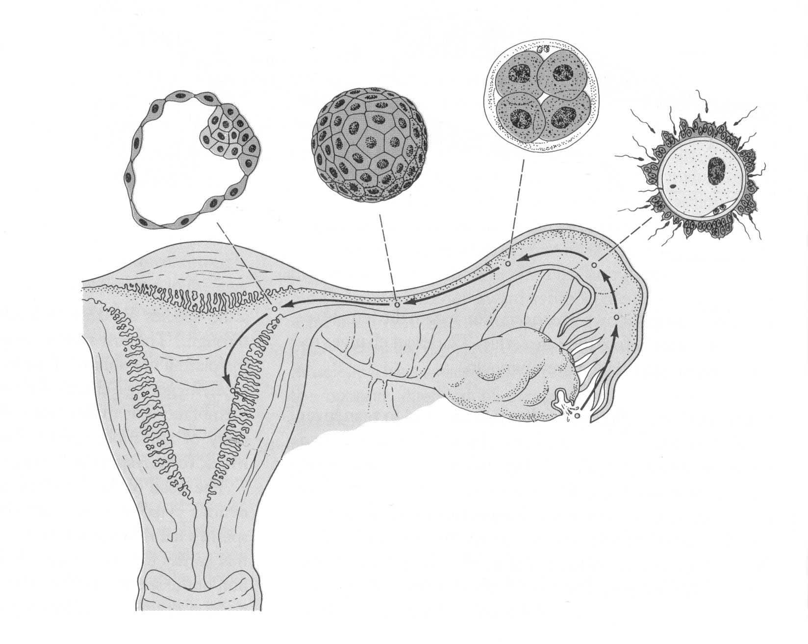

1. Describe how the blastocyst implants into the endometrium and also explain why implantation is necessary?
2. If implantation occurs, the embryo will secrete a hormone known as human chorionic gonadotropin (HCG). What is the function of this hormone?
3. The inner cell mass of the blastocyst forms the embryo. It initially divides into three primary germ layers. Name these layers and give two examples of tissues that form from each.
4. The zygote, morula and blastocyst provide sources of stem cells. What are stem cells?
5. There are three types of stem cells: totipotent, pluripotent and multipotent. Describe the differences between these types of cells.
6. Below is a diagram of a four-week-old embryo. Label this diagram using the listed terms on the right.

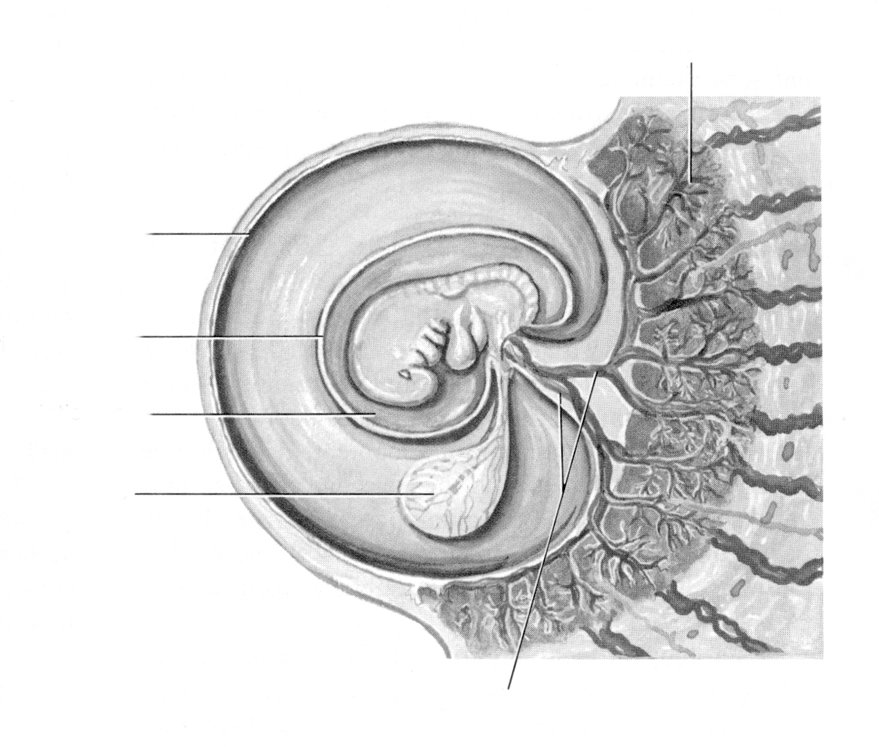

Chorion

Placenta

Yolk sac

Amniotic fluid

Amnion

Umbilical cord

1. Describe the importance of the chorion and the amnion.
2. Why is the yolk sac of little importance in humans?
3. Suggest why the heart is one of the very first structures to develop in the embryo.
4. At what age does an embryo become a foetus?
5. The diagram below shows a developing foetus in the uterus. Name the parts of the following diagram labelled A to G.

**G**

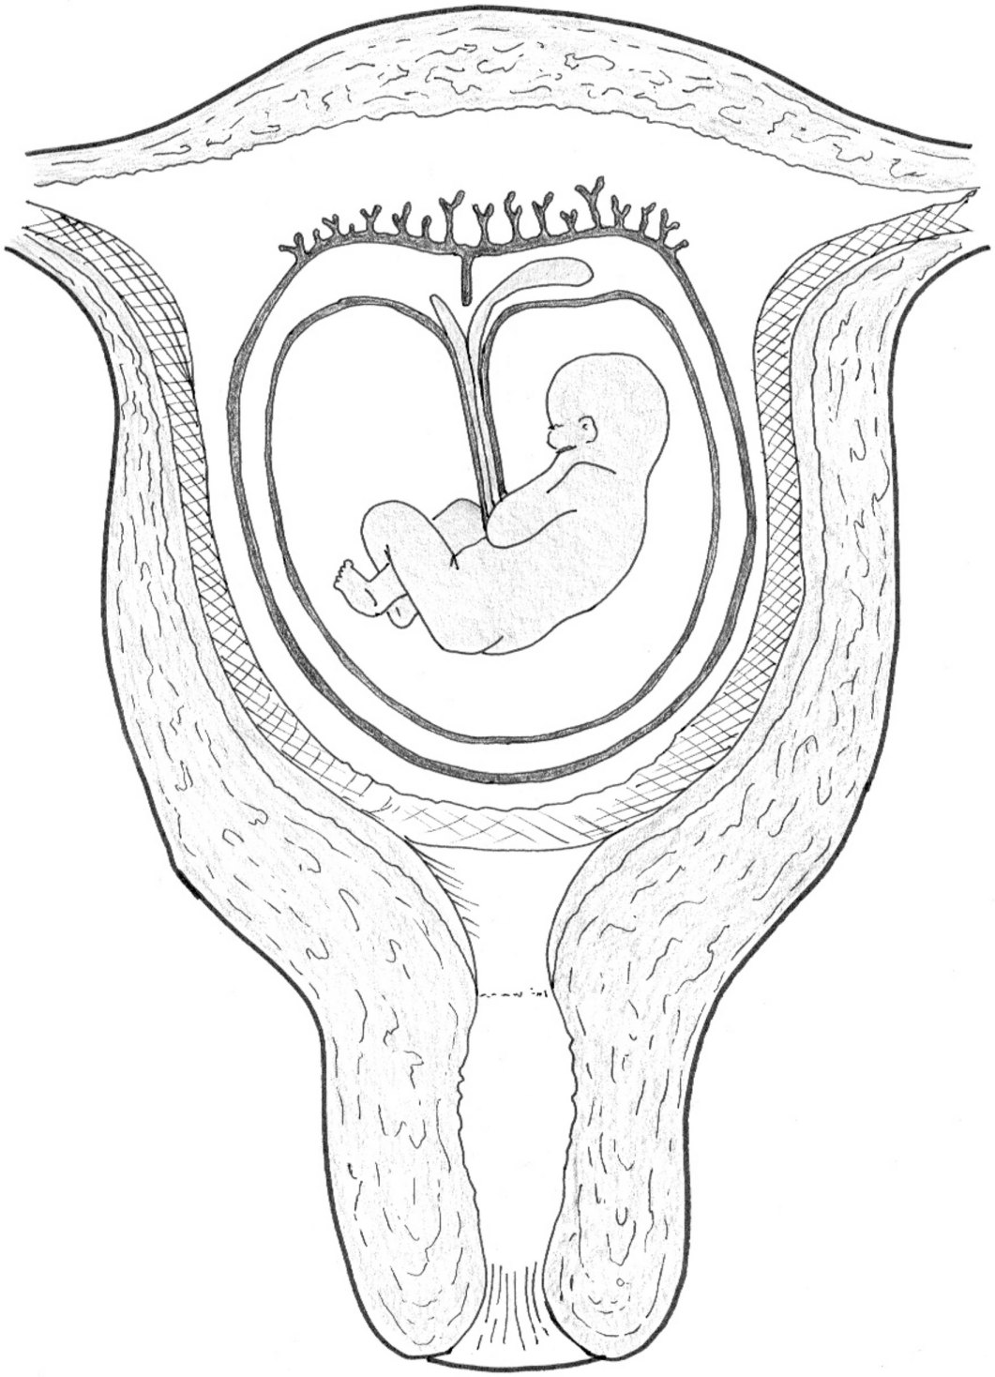

**C**

**F**

**A**

**B**

**E**

**D**

1. What stage of pregnancy is shown: early, middle or late? Give two reasons for your answer.
2. Give two functions of the fluid E.
3. Structure G contains numerous capillaries forming a total surface area of around 14 m2. State one advantage that this large capillary surface area gives to the function of A.
4. By which cellular process would nutrients move from the maternal blood to the foetal blood?
5. Which structure carries the nutrients from the chorionic villi to the foetus?
6. Name three nutrients that move from the mother to the foetus across the placenta.
7. Name two metabolic wastes that move from the foetus to the maternal blood.
8. Teratogens are substances that damage the structure of the developing foetus. Why is the foetus particularly prone to damage towards the end of the first trimester (2-3 months)?

**FOETAL GROWTH AND DEVELOPMENT**

1. Graph the foetal length and mass against time. Use a line graph and do not break the axes.

|  |  |  |
| --- | --- | --- |
| Time (weeks) | Length (mm) | Mass (g) |
| 0 | 0 | 0 |
| 1 | 0.2 | 0.01 |
| 2 | 0.5 | 0.05 |
| 3 | 2.5 | 0.2 |
| 4 | 6 | 0.5 |
| 5 | 12 | 0.5 |
| 6 | 16 | 1 |
| 7 | 19 | 2 |
| 8 | 26 | 6 |
| 9 | 38 | 15 |
| 12 | 90 | 30 |
| 16 | 150 | 180 |
| 21 | 300 | 450 |
| 25 | 350 | 875 |
| 30 | 400 | 1425 |
| 34 | 450 | 2375 |
| 38 | 500 | 3250 |

1. Clearly mark on the graph when the following developmental milestones occur:

* Embryo becomes a foetus
* Arm and leg buds develop
* ‘Tail’ disappears
* PE03327_Bone begins to deposit in skeleton
* Fingernails and toenails appear
* Testes descend in a male
* All systems but respiratory are functional
* Eyes open

1. During which of the following trimesters is the increase in length most rapid?

|  |  |  |  |  |  |  |  |
| --- | --- | --- | --- | --- | --- | --- | --- |
| 0-3 months |  |  | 4-6 months |  |  | 7-9 months |  |

1. How do you know this from the graph?
2. In which period of pregnancy is it most crucial that the mother avoid taking drugs?

|  |  |  |  |  |  |  |  |
| --- | --- | --- | --- | --- | --- | --- | --- |
| 0-3 months |  |  | 4-6 months |  |  | 7-9 months |  |

1. Why is the foetus more vulnerable to drugs during this period?
2. During which of the following trimesters is the increase in mass most rapid?

|  |  |  |  |  |  |  |  |
| --- | --- | --- | --- | --- | --- | --- | --- |
| 0-3 months |  |  | 4-6 months |  |  | 7-9 months |  |

1. How do you know this from the graph?
2. What is the value of having the rapid increase in mass occur in this trimester?
3. What is the name of the process that increases the number of cells as the foetus grows?

**PE03327_HUMAN GROWTH**

1. Graph the mass of females and males against age. Use a line graph.

|  |  |  |  |  |  |
| --- | --- | --- | --- | --- | --- |
|  | Females | |  | Males | |
| Age (years) | Mass (kg) | Width of hips (mm) |  | Mass (kg) | Width of hips (mm) |
| 0 (Birth) | 3.36 | 77 |  | 3.4 | 81 |
| 2 | 12.29 | 141 |  | 12.56 | 144 |
| 4 | 16.42 | 165 |  | 16.51 | 169 |
| 6 | 21.09 | 188 |  | 21.91 | 191 |
| 8 | 26.35 | 205 |  | 27.26 | 207 |
| 10 | 31.89 | 222 |  | 32.61 | 220 |
| 12 | 39.74 | 249 |  | 38.28 | 235 |
| 14 | 49.17 | 269 |  | 45.81 | 258 |
| 16 | 53.07 | 280 |  | 58.83 | 274 |
| 18 | 54.39 | 284 |  | 63.05 | 280 |

1. From your graph you should be able to see four stages of growth. Give an approximate age for the start and finish of each of these stages in males and females.
2. At which two stages are males growing the fastest in mass?
3. At which two stages are females growing the fastest in mass?
4. Describe the difference in the pattern of growth in males and females between 10 and 18.
5. At what age does the adolescent growth spurt happen in:

(a) Males

(b) Females

1. Name the hormones that drive the changes at puberty in males and females, respectively.
2. What changes occur during puberty in males?
3. What changes occur during puberty in females?
4. What is the significance of the greater hip width of females after maturity?

**ARTIFICIAL REPRODUCTIVE TECHNOLOGY**

The table below represents a summary of the use of Artificial Reproductive Technology in the United States in 2004. Use the information in this table to help you answer the questions below.

|  |  |  |  |  |  |  |  |  |
| --- | --- | --- | --- | --- | --- | --- | --- | --- |
| **ART CYCLE PROFILE** | | | | | | | | |
| **Type of ART**[**a**](http://apps.nccd.cdc.gov/ART2004/nation04.asp#footnote) | |  | | **Patient Diagnosis** | | | | |
| IVF | >99% | **Procedural Factors:** | |  | Tubal factor | 11% | Other factor | 8% |
| GIFT | <1% | With ICSI | 58% |  | Ovulatory dysfunction | 6% | Unknown factor | 11% |
| ZIFT | <1% | Unstimulated | <1% |  | Diminished ovarian reserve | 12% | *Multiple* *Factors*: |  |
| Combination | <1% | Used gestational carrier | <1% |  | Endometriosis | 6% | Female factors only | 12% |
|  |  |  | |  | Uterine factor | 1% | Female & male factors | 18% |
|  |  |  | |  | Male factor | 17% |  |  |

|  |  |  |  |  |  |  |
| --- | --- | --- | --- | --- | --- | --- |
| **2004 PREGNANCY SUCCESS RATES** | |  | |  | | |
| **Type of Cycle** | **Age of Woman** | | | | | |
| **Fresh Embryos from Nondonor Eggs** | **<35** | | **35–37** | | **38–40** | **41–42**[**c**](http://apps.nccd.cdc.gov/ART2004/nation04.asp#footnote) |
| Number of cycles | 40,853 | | 21,019 | | 19,174 | 8,487 |
| Percentage of cycles resulting in pregnancies | 42.5 | | 35.5 | | 26.5 | 17.3 |
| Percentage of cycles resulting in live births [b](http://apps.nccd.cdc.gov/ART2004/nation04.asp#footnote) | 36.9 | | 29.3 | | 19.5 | 10.7 |
| Percentage of retrievals resulting in live births [b](http://apps.nccd.cdc.gov/ART2004/nation04.asp#footnote) | 40.2 | | 33.3 | | 23.2 | 13.3 |
| Percentage of transfers resulting in live births [b](http://apps.nccd.cdc.gov/ART2004/nation04.asp#footnote) | 42.7 | | 35.5 | | 25.3 | 14.8 |
| Percentage of transfers resulting in singleton live births | 27.3 | | 24.3 | | 19.0 | 12.3 |
| Percentage of cancellations | 8.4 | | 12.0 | | 15.8 | 19.5 |
| Average number of embryos transferred | 2.5 | | 2.7 | | 3.0 | 3.3 |
| Percentage of pregnancies with twins | 32.7 | | 28.0 | | 21.2 | 14.5 |
| Percentage of pregnancies with triplets or more | 5.1 | | 5.6 | | 4.4 | 2.5 |
| Percentage of live births having multiple infants [b](http://apps.nccd.cdc.gov/ART2004/nation04.asp#footnote) | 36.1 | | 31.5 | | 24.9 | 16.8 |
| **Frozen Embryos from Nondonor Eggs** | | | | | | |
| Number of transfers | 8,790 | | 4,123 | | 2,618 | 765 |
| Percentage of transfers resulting in live births [b](http://apps.nccd.cdc.gov/ART2004/nation04.asp#footnote) | 30.6 | | 27.7 | | 23.1 | 18.7 |
| Average number of embryos transferred | 2.5 | | 2.6 | | 2.7 | 2.9 |

|  |  |  |
| --- | --- | --- |
|  | **All Ages Combined** [**d**](http://apps.nccd.cdc.gov/ART2004/nation04.asp#footnote) | |
| **Donor Eggs** | **Fresh Embryos** | **Frozen Embryos** |
| Number of transfers | 9,283 | 4,439 |
| Percentage of transfers resulting in live births[b](http://apps.nccd.cdc.gov/ART2004/nation04.asp#footnote) | 50.5 | 30.5 |
| Average number of embryos transferred | 2.4 | 2.7 |

**a**Reflects patient and treatment characteristics of ART cycles performed in 2004 using fresh nondonor eggs or embryos.   
**b** A multiple-infant birth is counted as *one* live birth.   
Source: http://apps.nccd.cdc.gov/ART2004/nation04.asp

1. What is in vitro fertilisation?
2. What is the difference between GIFT and ZIFT?
3. Under what conditions is it likely that ICSI would be used?
4. Of all the couples who use artificial reproductive technology, 17% do so because there is a problem with male fertility. What is the most likely problem affecting male fertility?
5. Women are generally given a fertility drug as part of the treatment. What is the specific purpose of the drug?
6. Why is the average number of embryos transferred higher for older woman?
7. Why are multiple births more common when using artificial reproductive technology?
8. Any embryos that are not used in the initial transfer are frozen. The percentage of live births is generally lower for frozen embryos when compared to fresh embryos. Suggest reasons for this.
9. Overall donor eggs tend to result in a greater percentage of live births. Suggest some reasons for this.

Consider the following scenario:

*After seven years of trying to have a child, Maria and Dean decided to approach a fertility clinic for help. Previous damage to Maria’s fallopian tube made her a candidate for zygote in vitro fertilisation (ZIFT). Four of the pre-embryos (zygotes) were inserted into Maria’s lower fallopian tube in the hope that they would implant and establish a pregnancy. The remaining pre-embryos were frozen at -90oC for future IVF procedures if needed. No pregnancy resulted and subsequently Maria and Dean decided to divorce. Maria requested the custody of the frozen pre-embryos from the IVF treatment. Dean insisted that the fertility clinic not release the pre-embryos, as he no longer wished to become a parent.*

1. In your opinion, should either Maria or Dean be able to claim ‘custody’ of the pre-embryos? Justify your answer.
2. Do you consider a pre-embryo (zygote) to be a ‘living thing’?
3. Currently in Australia pre-embryos are stored for five years. At the end of five years, what would you consider to be a reasonable and ethical fate for the pre-embryos? (Possibilities include: use in research, donation to other infertile couples or disposal.)